**How to use**

1. git clone <https://github.com/Alissa-lim/IOC_Validator.git>
2. cd IOC_Validator
3. pip install requirements.txt
4. Python
   1. import nltk
   2. nltk.download('wordnet')
   3. 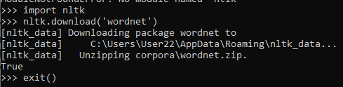
   4. Exit()
5. python IOC_Validator.py
   1. 
6. Input either 1 for Single URL or 2 for URL containing text file
   1. For option 1 - Input a single URL:
      1. 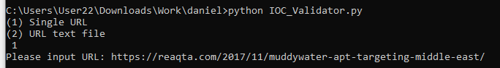
   2. For option 2 – Input fill path to file containing URLs:
      1. 
7. Program will run through each URL in the text file ort from the input and print out “Reading completed” when done:
   1. 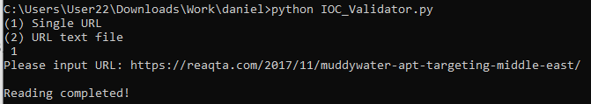
8. View content of each IOCs found in each report by the folder name:
   1. 
   2. Inside each folder is an IOCs folder and a URL folder:
   3. 
   4. Inside the IOCs folder is each different type of IOCs
   5. 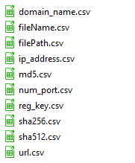
   6. 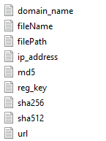
   7. 
9. 2 database files will also be created in the same directory as where the application was run:
   1. 
      1. The table will contains the IOCs tagged to each URL tested
   2. 
      1. This table will contain list of URLS that was successfully crawled
      2. 